I'm afraid of missing details while studying. What should I do?
Why you won't really miss details
The fear of forgetting or missing out on details is valid and understandable. Fortunately, it is also unnecessary. This article will explain why.
Learning as a Swiss cheese model
A learning system involves multiple stages of studying. Missing a detail now simply means we will pick it up in a later stage, potentially using a technique that is much more suited for that detail.
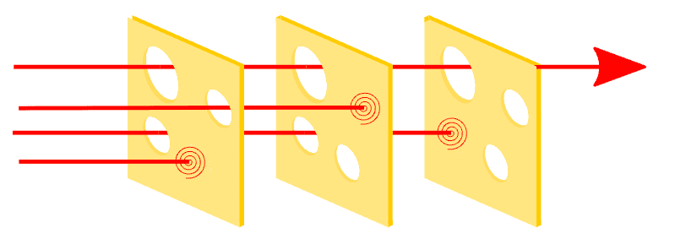
Swiss cheese model. Source: Wikipedia
In this diagram, you can see that multiple layers reduce the risk of errors. For learning systems, each layer represents an encoding or retrieval session. The holes in each session reflect the methods we use. A complete learning system should use methods of various orders of learning, with enough retrieval practice to catch knowledge gaps.
What slipped through?
You can see that one error (the red arrow) managed to slip through all three layers. This indicates a gap in the system. For learning, a common gap is that many learning systems lack a higher-order learning method, so questions that involve conceptual inter-relationships and nuance are missed. These are often called 'curveballs'.
Not all information is equal
Not all information is appropriate and relevant to learn immediately. You wouldn't think to learn high school biology by dissecting a biological science Ph.D. thesis and working your way backwards. We understand that it would be far too overwhelming with information we are not ready to process and make sense of.
The same is true for even a single textbook chapter. Some sentences, facts, and pieces of information are slightly too detailed for us to process them easily. Returning to this once we have more background knowledge often makes this information easier to process and understand.
Furthermore...
Most textbooks and curriculums are not designed so that the information is delivered to you in the best possible way in the best possible order. As everyone has different levels of background knowledge and ways of making sense of information, this is realistically impossible, even with the best teacher.
Learning details too early makes it harder to remember
Isolation leads to information death. When information is learned in isolation, such as with most memorisation techniques, without connecting it clearly to the big picture or other related concepts, our retention suffers.
Instead, if we were to come back to it when we have a stronger organisational structure. Even tiny details can make more sense and seem obvious when we know more about the other related ideas.
Ironically, focusing on details because we are afraid of missing them makes us much more likely to forget them!
Beware
Dangerously, this kind of learning creates the illusion of fluency. This is when we think we have a high level of mastery (e.g. because we created some notes), but our ability to retrieve it may be poor because it was encoded weakly. If you've ever felt confident because you had perfect notes but still underperformed, you have fallen into this trap.
Our systems are battle-tested
Our learning systems are built to be highly practical under realistic academic and learning pressures. This is what makes our methods so unique compared to other overly theoretical or idealistic methods.
Common reasons for low retention
- Insufficient or inappropriate spaced interleaved retrieval
- Poor quality encoding
- Incomplete learning system with gaps (sometimes due to rushing or selective learning)
- Limitations due to poor self-management, such as excessive procrastination or urgency trapping

